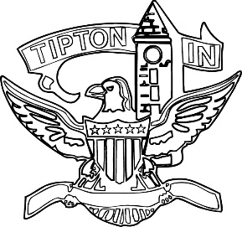
Agenda
City of Tipton
Plan Commission
January 16, 2025
6:00 p.m.

The City of Tipton Plan Commission will hold its regularly scheduled meeting on Thursday, January 16, 2025, at 6:00 p.m., at the Tipton City Building meeting room, 216 South Main Street, Tipton, Indiana.

Call to Order and Pledge of Allegiance

Roll Call

Modifications to the Agenda

Election of Officers

- President
- Vice President
- Secretary
- County Liaison
- Plat/Development Plan Review
Committee

Approval of Minutes
a) November 14, 2024 Meeting Minutes

Public Hearings

a) CTI-ZO-28-24 Subdivision Control Ordinance Amendment

Staff Reports

a) City BZA report.
b) Standing Committee report

Old Business
a) None.

New Business
a) None.

Public Comment

Adjournment

