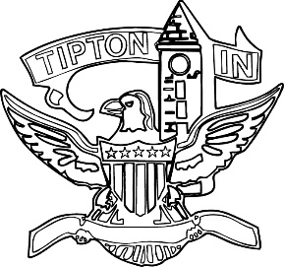
Agenda
City of Tipton
Board of Zoning Appeals
January 15, 2025
6:00 p.m.

The City of Tipton Board of Zoning Appeals will hold its regularly scheduled meeting on Wednesday, January 15, 2025, at 6:00 p.m., at the Tipton City meeting room, 216 South Main Street, Tipton, Indiana.

Call to Order and Pledge of Allegiance

Roll Call

Modifications to Agenda

Election of Officers
- Chairman
- Vice-Chairman
- Secretary

Approval of Minutes
a) October 9, 2024 Meeting Minutes.

Public Hearings
None.

Old Business
a) CTI-V-18-24 Tipton County Foundation findings of fact.

Adjournment

